
AMERICAN INTERNATIONAL UNIVERSITY-BANGLADESH
Faculty of Science and Technology
Department of Computer Science
CSC 3215: Web Technologies
Semester: Summer 2025-26 | Group No: 6 | Section: AA

Group Members:
SL. | Student ID | Name | Role | Signature
1 | 23-54819-3 | MD. SHAJIB SARDER | Group Leader | Shajib
2 | 23-55230-3 | PUSPITA DAS | Member | Puspita
3 | 22-48362-3 | OISHE JAHAN | Member | Oishe
4 | 23-53686-3 | FARHAN KABIR | Member | Farhan

Project Title
Online Book Shop Management System
Short Description
The Online Book Store System is a web-based system designed to manage the daily activities of an online bookstore efficiently. The system allows customers to register, log in, browse and search books, add items to a cart, update or remove cart items, proceed to checkout, make payments, and view their order history. Vendors can register, submit new books, view approval status, and update or search their own book prices and quantities. System Administrators can manage books and categories, view customer orders, generate sales reports, and approve or reject vendor books. Staff members handle customer support tickets, track order/shipment status, and moderate customer book reviews. The system aims to reduce manual work, improve order and inventory management, and provide better coordination between customers, vendors, staff, and administrators.
Introduction
Bookstores handle different types of activities every day, including customer registration, book browsing, cart management, vendor book submissions, order processing, and customer support. Managing these activities manually or through disconnected tools can be time-consuming and may lead to errors or difficulties in tracking orders and inventory. The Online Book Store System is developed to provide a centralized platform for managing these activities. Customers can search for books and manage their orders, while vendors can submit listings and track approvals. Staff members can update order statuses, respond to customer support tickets, and moderate reviews, while administrators can oversee book listings and sales reports. The system therefore helps make online bookstore operations more organized, efficient, and user-friendly.
Background Study
Traditionally, many bookstores handle customer orders, book inventory, vendor submissions, and support requests using paper-based records or separate manual processes. Such approaches can make it difficult to maintain accurate records, track orders, manage payments, and provide timely customer service. With the development of web-based management systems, these activities can be integrated into a single platform. A bookstore management system can provide different functionalities for different users according to their roles. Customers can manage their purchases, vendors can submit and update book details, staff can handle fulfillment status updates, shipment tracking and customer queries, and administrators can review orders and approve vendor submissions. The Online Book Store System is designed based on this concept. It integrates book catalog management, shopping cart operations, vendor listing approvals, order tracking, sales reporting, and customer support into one system. This helps reduce manual effort, improve information management, and make the overall bookstore management process more systematic.
ER Diagram
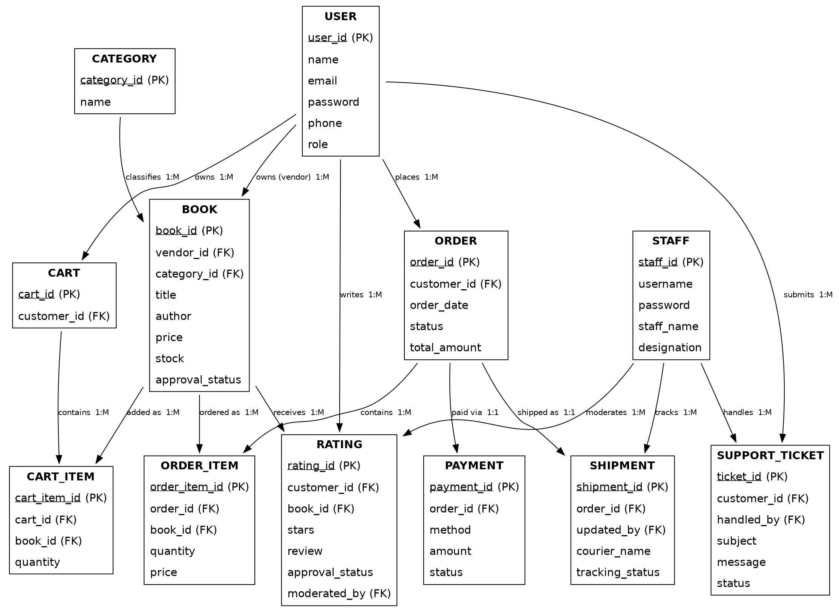
Use Case Diagram
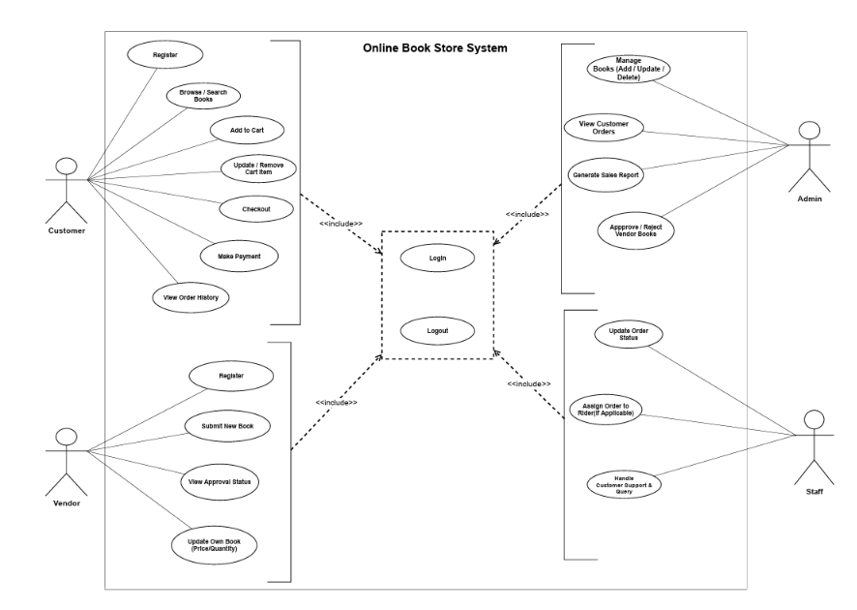
UI (Figma/Sketch)
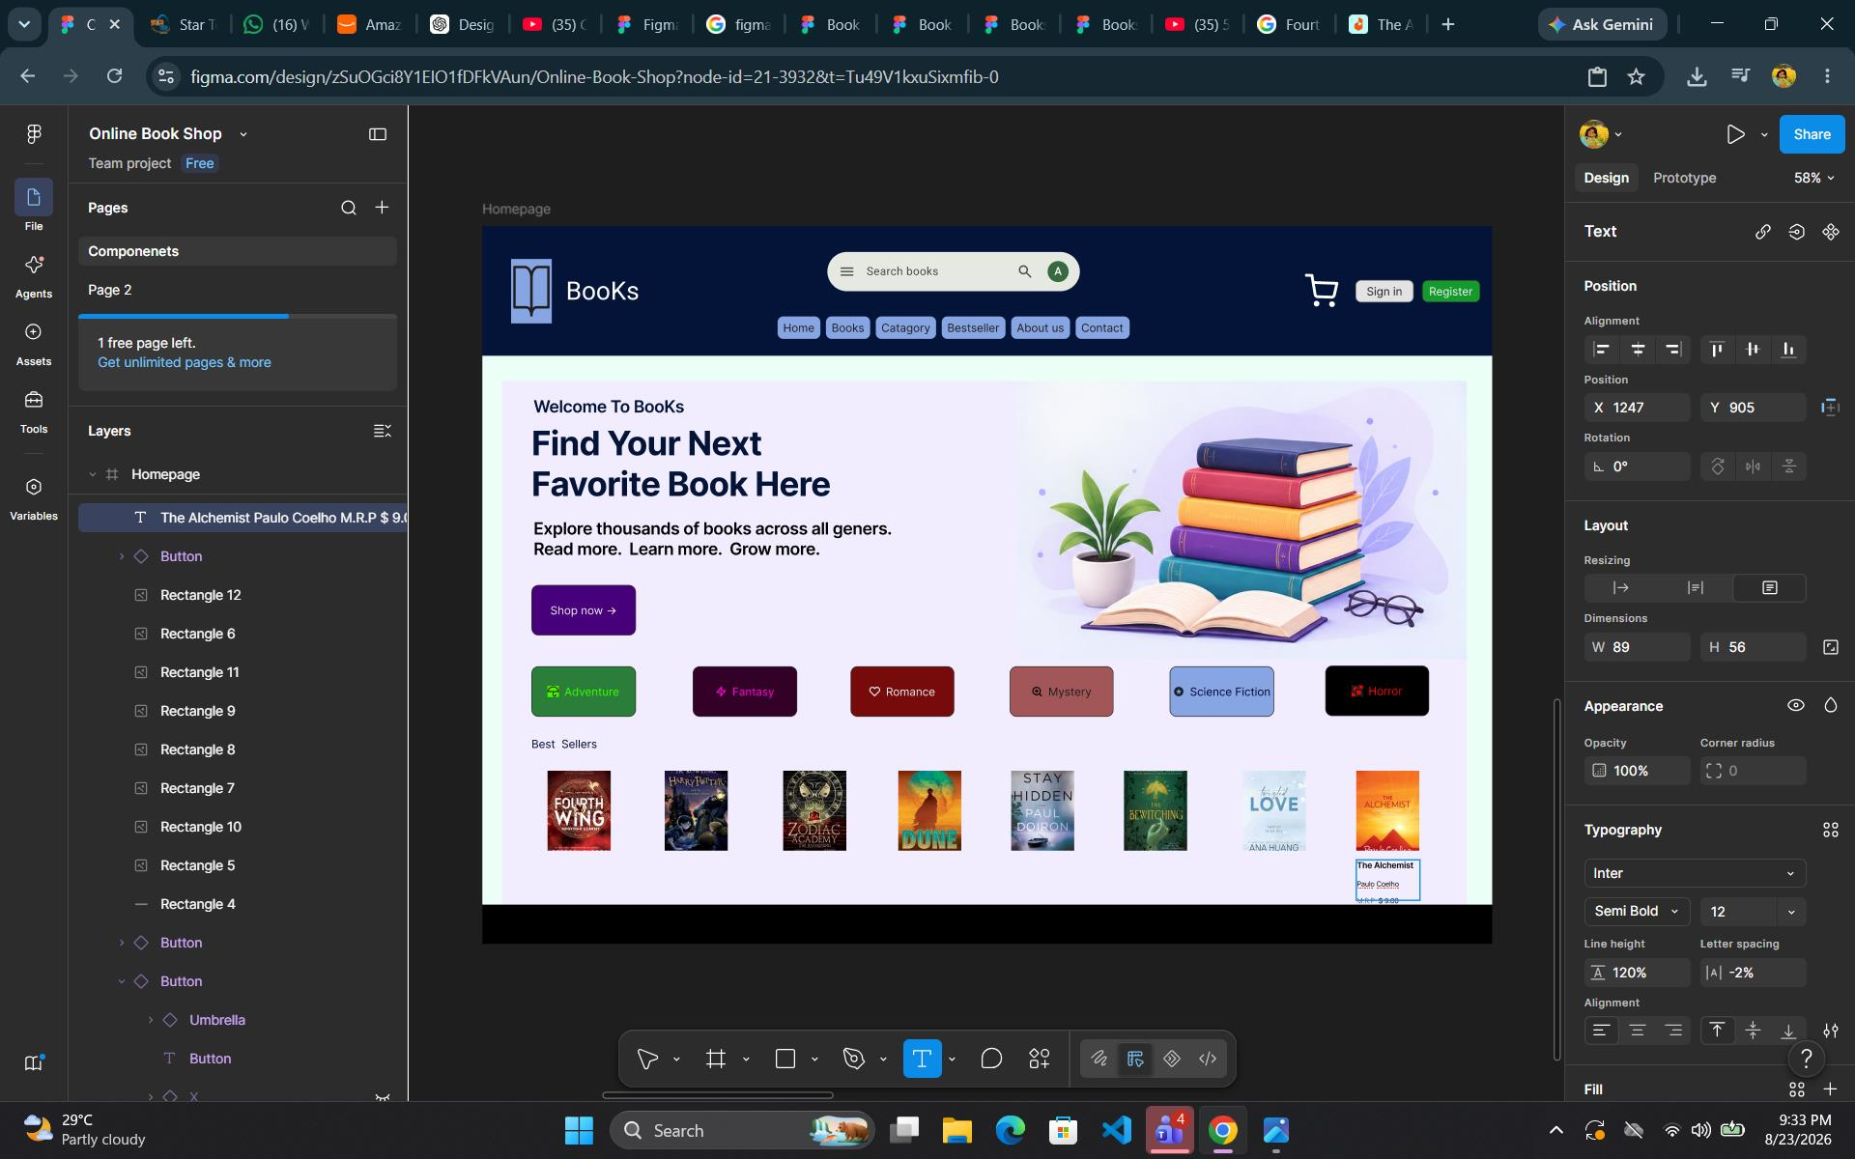

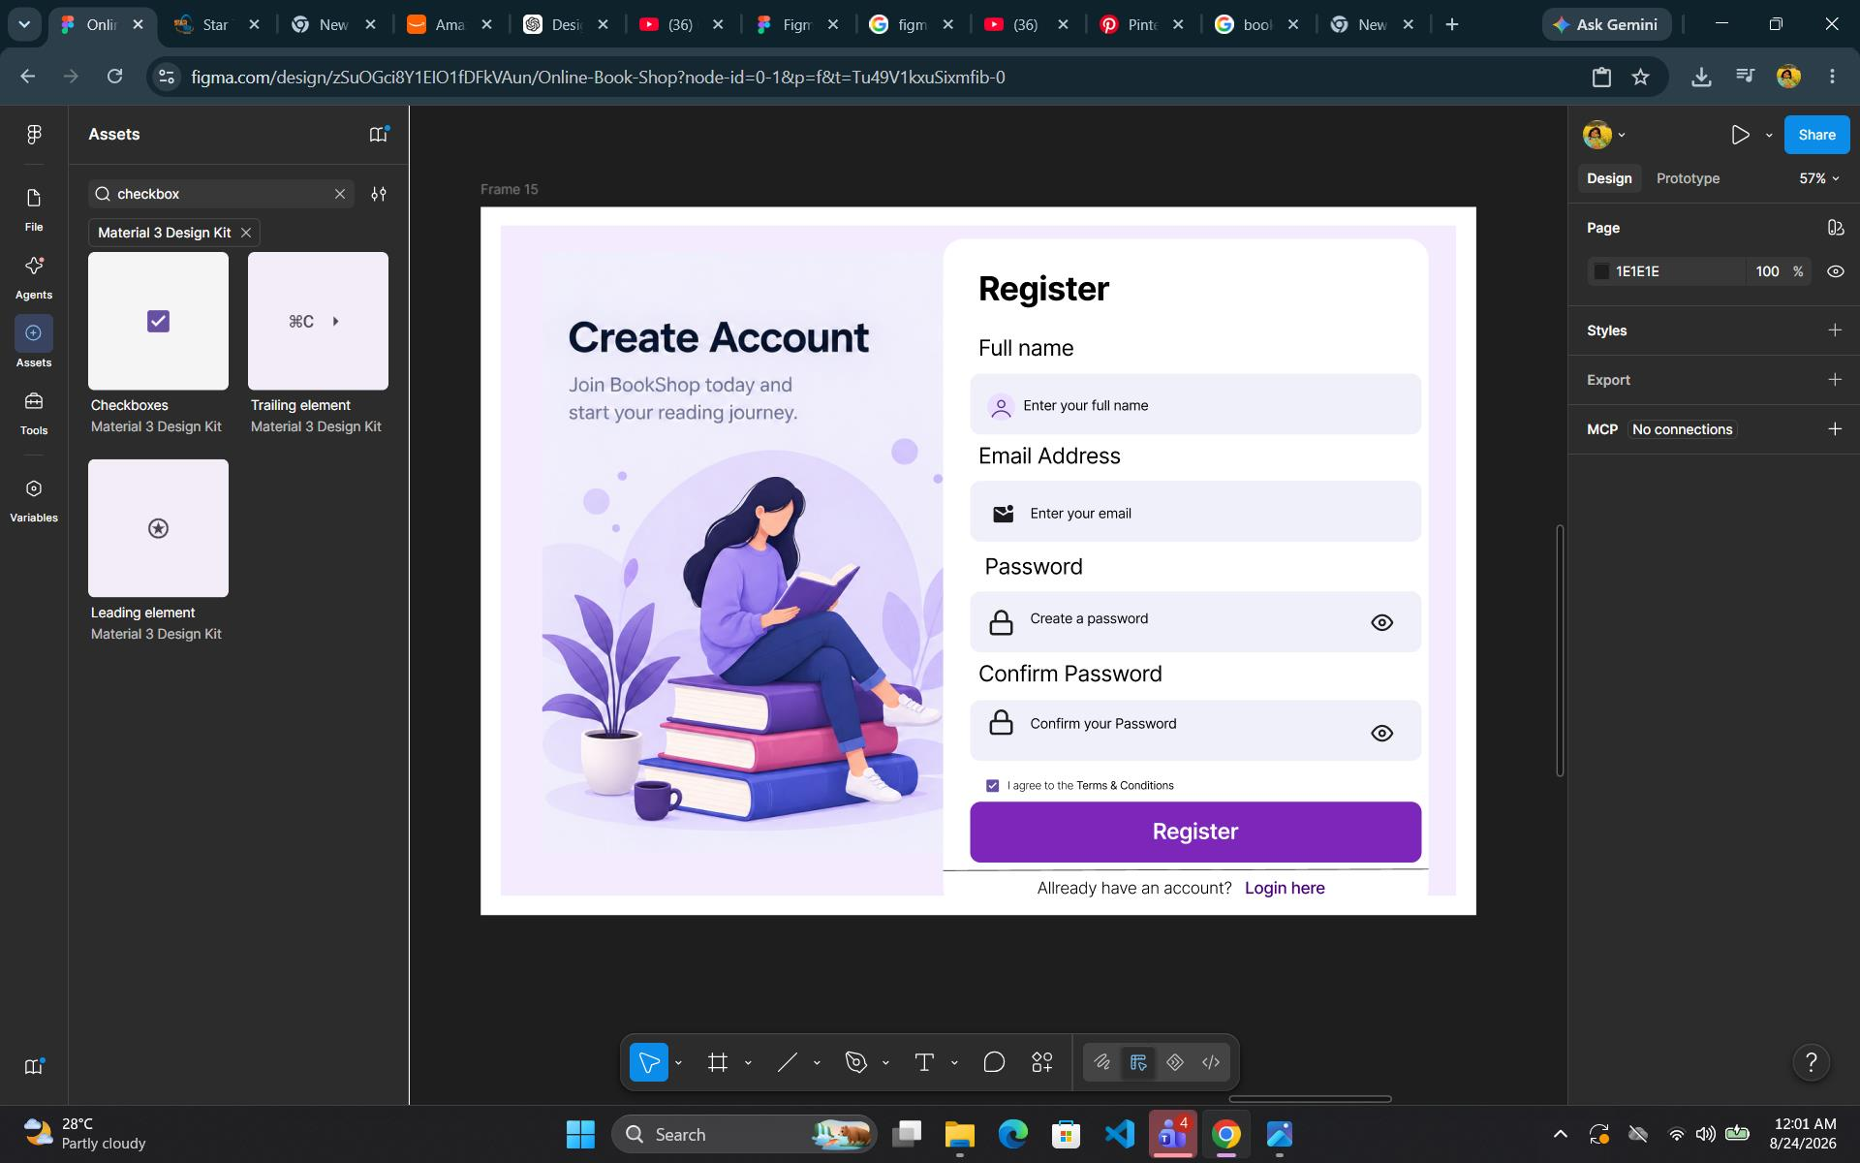
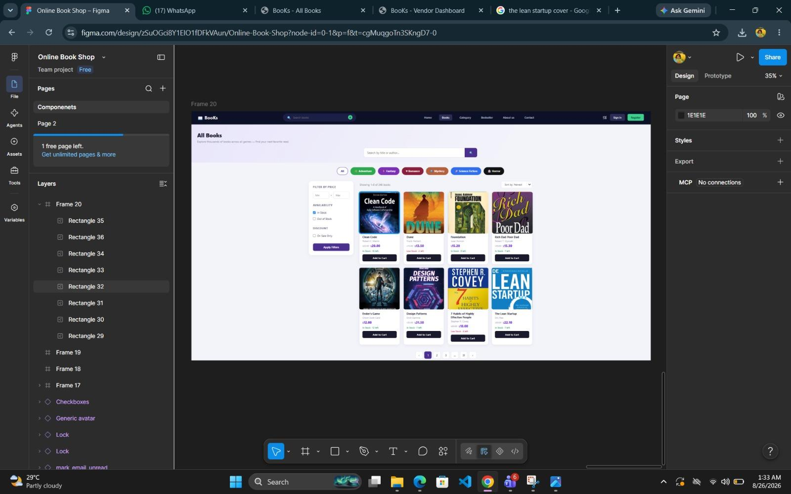
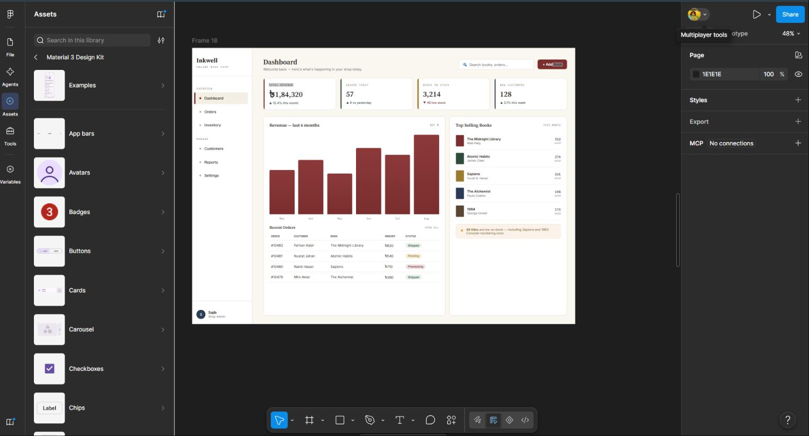
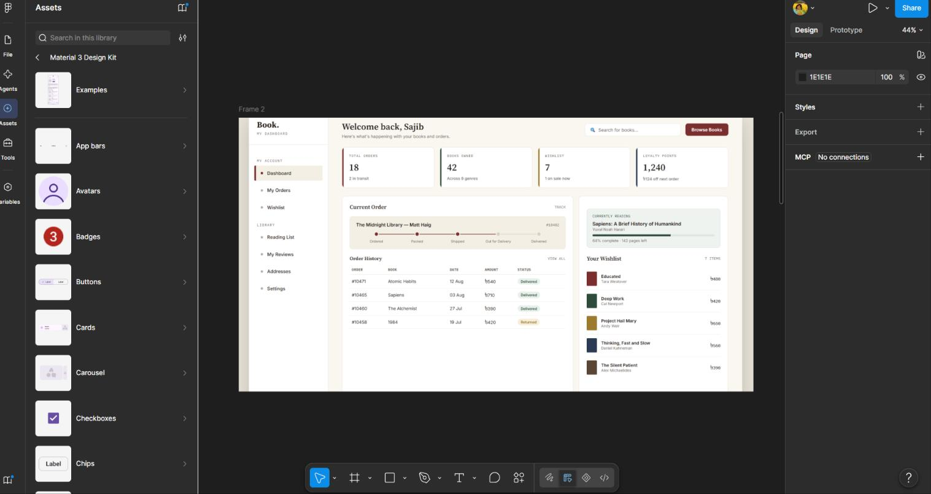
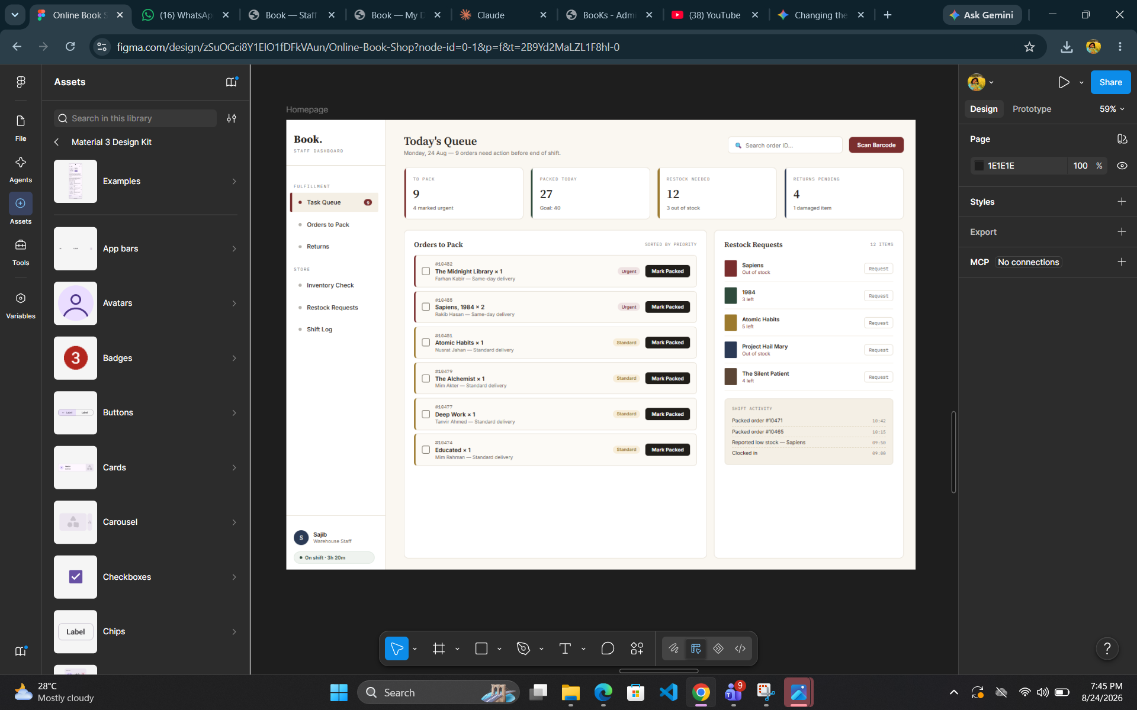
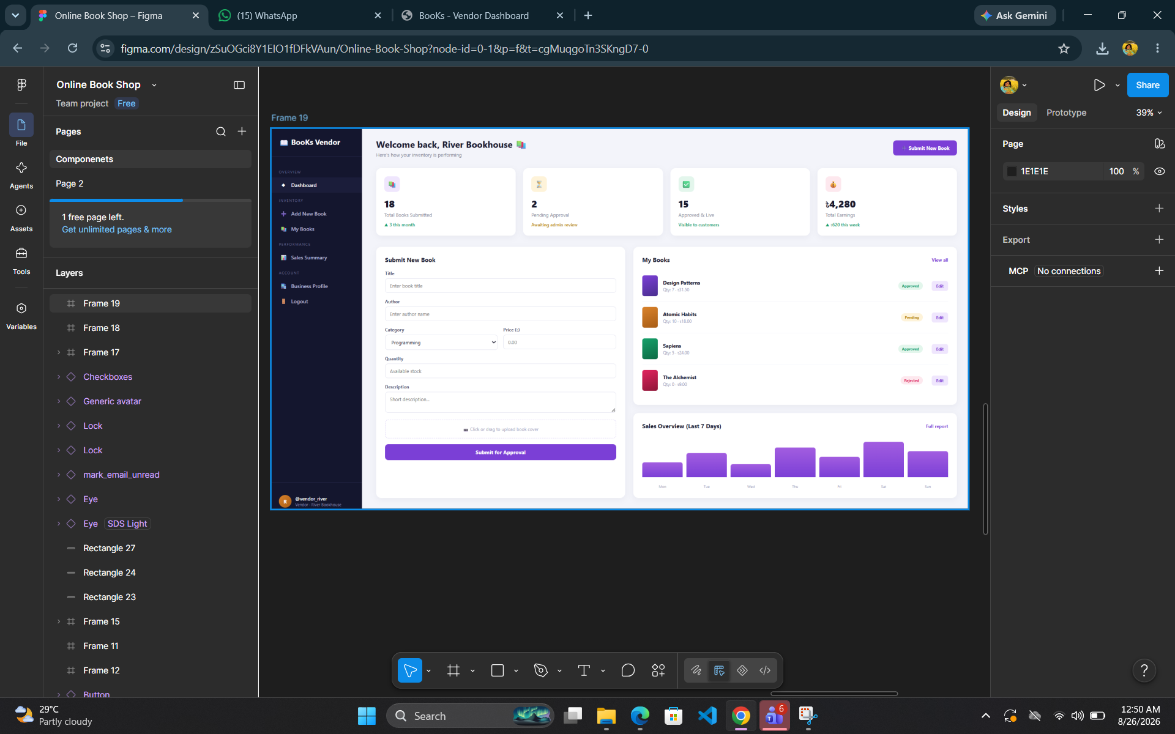
Types of Users
- Admin
- User
- Vendor
- Staff
Common Features (Available to All Users)
- Authentication
- Login to the system
- Logout from the system
- Session-based authentication
- Password storage (hashed)
- Role based dashboard
- Account Management
- Manage profile information (view, edit, delete)
- Dashboard
- Access a personalized dashboard after login
Specific Features by User Type
Features of Admin
- Book and Category Management
- Customer Order & Sales Report
- Vendor Book Approve System
Features of User
- Book Browsing & Search
- Shopping Cart
- Checkout with Multiple Payment Options
- Order History
Features of Vendor
- Book Submission for Approval
- Approval Status Tracking
- Stock/Price Update (own Book) - Create, Update, Delete
- Search Added Book
Features of Staff
- Customer Support Ticket Management (Open → In Progress → Resolved)
- Order / Shipment Tracking (Pending → Shipped → In Transit → Delivered)
- Book Review Moderation (Approve / Reject customer reviews)

N.B: Each user type must have at least 3 distinct features different from the others. Additional features may be added if desired. Proposals with generic, incomplete, or duplicated features across user types will receive reduced marks under the criteria below.

